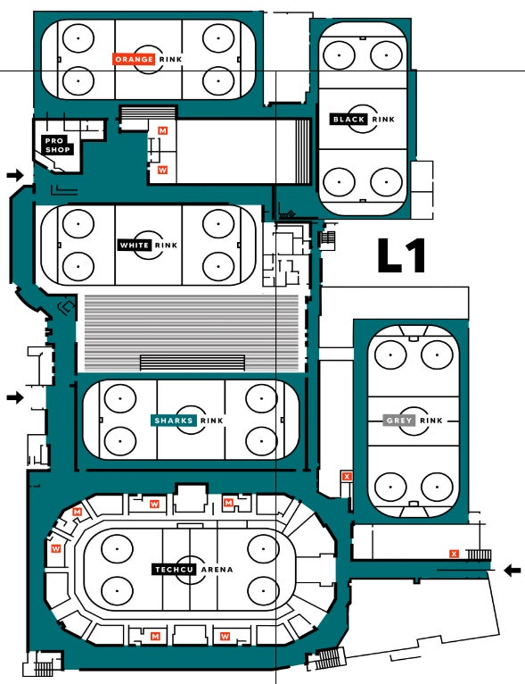
Judges, technical panel, music, photo, video, and announcing are here.
Judges, technical panel, music, and announcing
Entrance to Grey for skaters, spectators, officials.
Stairs for spectators going to watch in Grey
Spectator upstairs seating
----------------
Skaters entrance to ice.
Skaters enter the ice. Roping is set up to control flow and keep skaters and spectators apart. Spectators may not linger.
Skaters entrance. Registration is here and the entrance to the Sharks rink.
Entrance to Grey from Black
SVO Know Before You Go!

Hello Skaters and Coaches!

Solar4America Sharks Ice San Jose is located at 1500 South Tenth Street, San Jose, California 95112 at the corner of South Tenth Street and Alma Ave. Click here for parking options. SVO will be held on Aug 4-5, 2023. Schedules, starting orders, results and more, can be found on our website: https://www.peninsulaskatingclub.org/competitions

The facility houses six ice surfaces and we are using two of them: the Grey rink and the Teal/Sharks rink. We are using two entrances:
- the Sharks entrance is in the front and middle of the facility facing 10th St, between the main entrance and the entrance to the arena. The entrance will be marked with the Peninsula Skating Club sign. Upon entry, you will find the registration desk, tables for photography and video, and the apparel vendor with logo apparel available for purchase. The award podium will also be in the lobby. Awards can be picked up at the registration desk and the podium used for pictures. There will be no formal award ceremonies except for the Ernie Burden Award for the top Novice man freestyle skater.
- ERNIE BURDEN AWARD SCHEDULE FOR TOP NOVICE MAN FREESTYLE: Saturday Aug 5, after final results.
- The entry to the Grey rink is at the back of the facility. If you drive around the arena, you will find parking and the entrance to the Grey rink clearly marked. Skaters, coaches, and spectators may use this entrance.

In both rinks, the judges, technical panel, music & announcing, videographer, and photographer will be located opposite the bleachers/spectator viewing areas.
The Teal/Sharks rink has ample seating. Upon entering the rink from the lobby, spectators are to walk quickly past where the skaters are waiting to take the ice and move into the bleachers. The area needs to remain clear for the skaters. At the far end of the bleachers is the door that leads to the Grey rink. The grey rink has upstairs seating. Please note on the map where the stairs are located. These stairs also lead Calder’s Bar and Refuge, a warm rest spot that overlooks both rinks. Half of Calder’s will be curtained off for the officials and we ask that their privacy be respected. In Calder’s are two doors that lead to the seated viewing area.
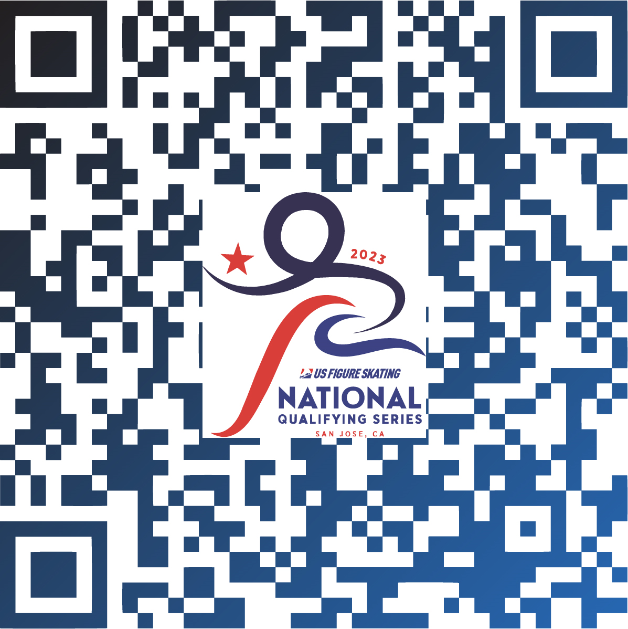

The link to the SafeSkate Handbook is below. All skaters should review and be aware of the guidelines for conduct and reporting.
https://www.peninsulaskatingclub.org/_files/ugd/2be1ce_69ccf18b023d498baa687d2651ec2434.pdf

SVO is a credentialled events. Credentials are issued at registration and all skaters and officials are to wear them at all times. Please go into EMS to make sure that you are compliant; all waivers and the medical registry should be green. See the charts on the next pages.
Note: Members who show as having any items incomplete in the reports can provide their compliance card from Members Only. The card shows the compliance role and end date. There are occasions where completed compliance items do not pull into the records. Members providing the compliance card showing the role and end date in the future can be credentialed. The missing item can be checked as viewed in the online check in page. Members can find their cards by logging in to Members Only and clicking the card icon next to their name on the home page. More compliance information can be found in the pdf sent along with this document.
Prior to checking in onsite, ALL COACHES AND SKATERS must have completed the Medical Registry and Emergency Contact through your competition portal. For completion of Medical Registry, emergency contact on the right-hand side of the page are the only required fields, however fill out as much information as you feel comfortable providing. If not completed and showing as a green checkmark within your competition portal, you may be asked to step out of line to complete and return once completed. A credential will be provided once all required items have been verified.
If you are solely a partner, access your competition season profile and complete your waivers and medical registry.
To view the steps described to complete missing medical registry or waivers, click here.
We encourage all participants to share the information they’re comfortable with (i.e. allergies) to ensure the local team can provide the appropriate care in the event of an emergency. However, the only required field on the form is the emergency contact. Information will be kept confidential and only provided to those who have a legitimate need.

